The religion trip to THE LIVE 蔡博雯401810501
語言一
Religion(Wednesday)
DR.王蔚婷
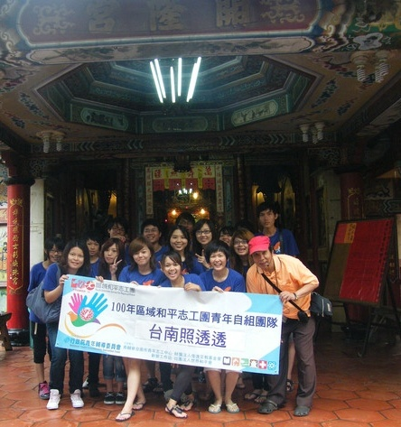開隆宮
↑ The red paper in the picture said that the process of the rite.
The person, wearing in red cap, is the history tour guide.
We are the volunteers to join the religion culture in Taiwan.

I t is the most famous temple for the children to have the rite of passage (做16歲)in Tainan culture. The rules are that the person takes part in the rite and the child wears the tradition blessing uniform, climbing over the palanquin. Through the history tour guide, I have learned that there is the meaningful activity for everyone even you were over sixteen. In the pass, it was important for the people to become the adult and it was as not only that you grew up and it told that you had the ability to support for the family. In the other word, you could earn more money to improve the living standard. Every year there is the big celebration in Tainan city and it is the best way to recollect the relationship for every family. The religion trip to LIVE lets me know more about how the growing affects the family and own self. The new born is the hope and the growing is the blessing.
The religion trip to THE LOVE 蔡博雯401810501
語言一
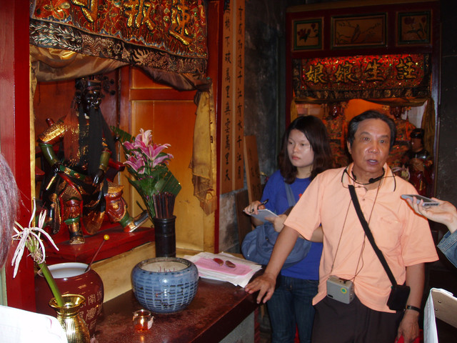
Religion(Wednesday)
DR.王蔚婷
重慶寺

速報司
←

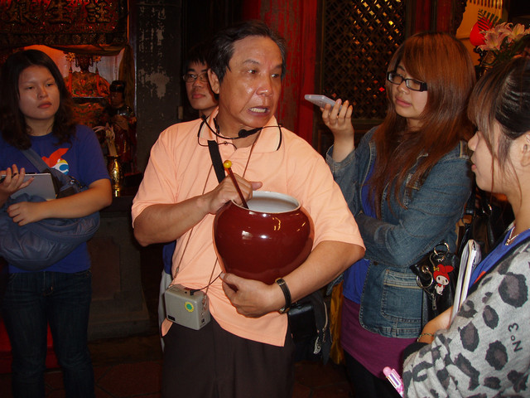
He is the god to solve the problem that the couple has an affair. The men/women can state your grievance by stirring the vinegar bowl and it is the same time the tears will drop into the bowl.
醋桶
←

In the temple there are conclusive of different kinds culture background (中國)and the sect of the religion.(喇嘛教, 佛教) The statue of the god had been destroyed in the war and regained the new one from china.

The religion has its own special culture that makes the people have the belief to live well and the sense of the safety. However, they are as the symbol of the more ways to seek out the problems and give the hope to face the reality. The helpless people have the support and release the stress.

The religion trip to THE SICK 蔡博雯401810501
語言一
Religion(Wednesday)
DR.王蔚婷
興濟宮
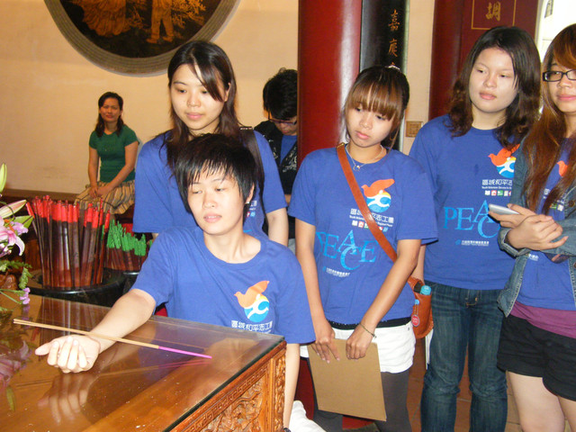
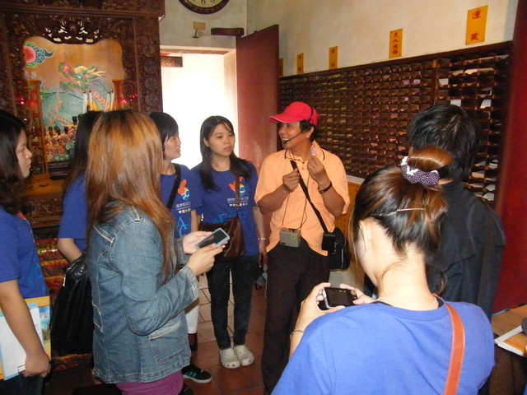
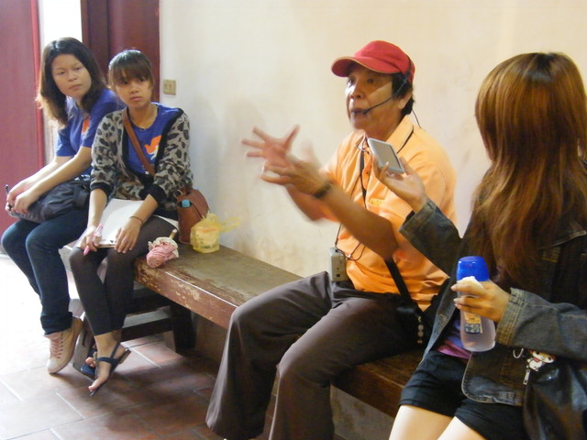

↑The gods in the temple belongs to Buddhism(觀世音) and Taoism(大道公).

The god(大道公)can analyze the symptoms of your illness by the incense. He can also give you the prescription and the medicine lists are divided into four parts in the temple. (小兒科,內科,外科,眼科) In the activity, we actually tried to pray for the prescription that the person didn’t have a sick. However, the god magically gave the prescription to relieve the summer heat in the hot summer day. The religion culture is deeply rooted in the local people, becoming whatever the sect you are that you would want to understand the special culture and history.
The religion trip to THE DEATH 蔡博雯401810501
語言一
Religion(Wednesday)
DR.王蔚婷
府城隍廟
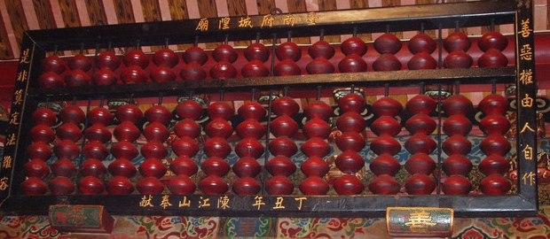
Abacus
←
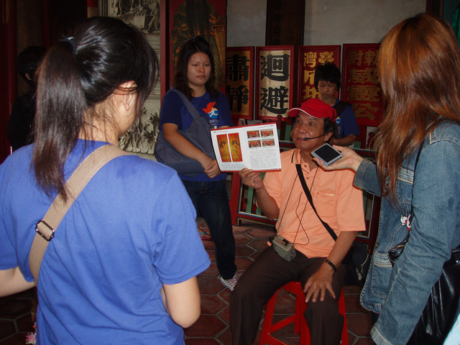
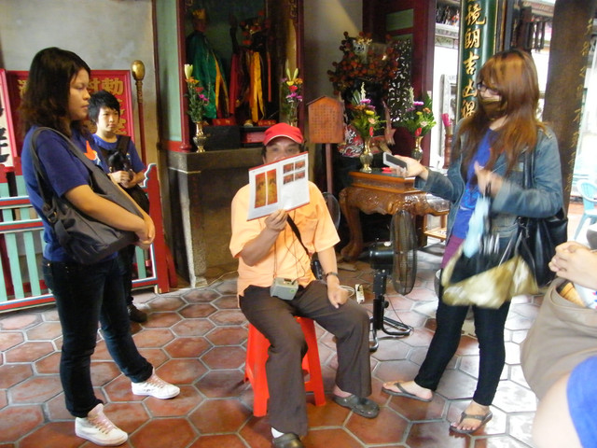
In the temple there is the huge abacus hung up at the top of the door. It means to calculate how many the good and bad deed you have.

←
七爺八爺
(Behind the tour guide)

While he told us many kinds of legends, they showed we need to do our best to not only do well but do selfless. Even though you are the person just doing only one good, you could also have the chance to become to the heaven.

While the religion is the club to re-bond the relationship and educate the people to behave well, it helps the society more in harmonious.

